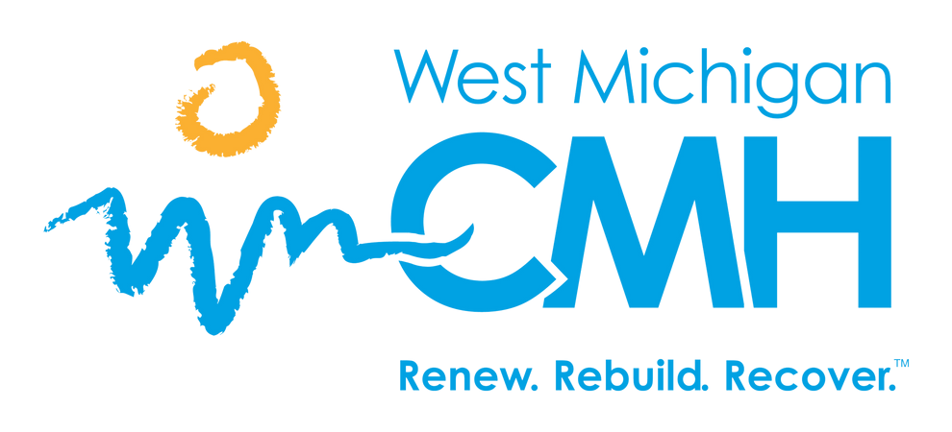

CORPORATE COMPLIANCE

It is the duty of the Compliance Officer to ensure that fraud, waste, and abuse is reported to the appropriate authorities. If you suspect fraud, waste or abuse or any other compliance issues, please report them using one of the following mechanisms below. All reporters are kept confidential and should be done in good faith.

Some other examples that may be reported to Corporate Compliance are:

Lying about credentials such as a college degree Billing for services that were not provided

Forgery or alteration of documents related to WMCMH services and/or expenditures (checks, contracts, purchase orders, invoices, etc.)

**Misrepresentation of information on documents (financial records and**

**medical records)**

Theft, unauthorized removal, or willful destruction of WMCMH records or property

To make a report please use one of the following methods: Email: [reports@wmcmhs.org](mailto:reports@wmcmhs.org)

Phone: 231-845-6294 or 1-800-992-2061

*Please call the hotline number for anonymous reports or use the MS Form there is a link and QR code. https://forms.office.com/r/kwNwwUSzSB 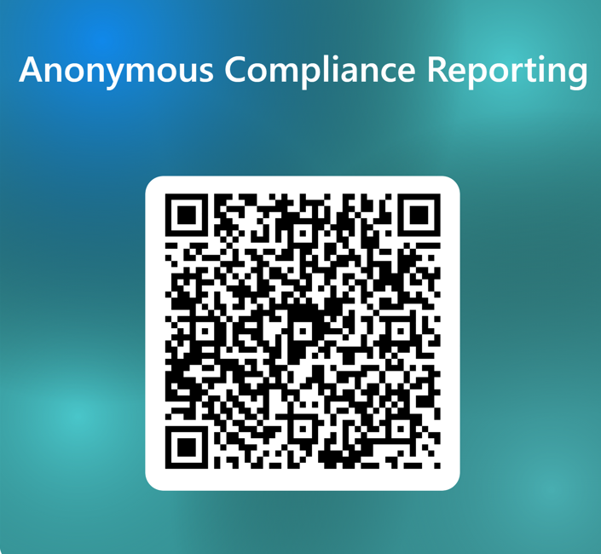.

[WWW.WMCMHS.ORG](http://WWW.WMCMHS.ORG/) 1-800-992-2061