WEST MICHIGAN COMMUNITY MENTAL HEALTH
WORK INSTRUCTION (WI)
Team Name | Work Instruction Name | Work Instruction Number
NQC | Completing CIRs & Debrief for Provider Network | NQC_Network_WI_31
Purpose and Objective | Estimated Time to Complete Work Instruction | Version #, Effective Date
 |  | Version #4, 11/8/24
Author | Approved By | Date
Kristin Graham | Betsy Reed-Henry | 11/8/2024
Policy Reference | Procedure Reference | Other References (if applicable)
2-12-8 | 5.1 and 5.2

INSTRUCTIONS:
Insert any materials, tools or safety equipment required to perform the task. Identify any risk(s) pertaining to this work instruction. If you are going to use any abbreviations/acronyms, provide those in the “ABBREVIATION/ACRONYM” table. In the ‘STEP NO.” column identify the step in which the instruction is required. In The “INSTRUCTION” column explain the step that is required. The “KEY POINTS” are for items that need attention or further comment. The “ILLUSTRATION, PICTURE, FIGURE, ETC.” column allows you to place a picture, figure, etc. to help the user navigate the steps. If you need to show a larger image, etc. you may place it at the bottom of the work instruction. If inserting a larger image ensure the reference # in the “Illustrations, picture, figure, etc.” is identified in the applicable step avoid confusion.

NOTE: If more rows are needed place your cursor to the left of an existing row and “click” the +

MATERIALS, TOOLS, SAFETY EQUIPMENT REQUIRED | POSSIBLE RISKS
CIR Form
CIR Debriefing Analysis Form
Faxing/Emailing Permissions to WM CMH

ABBREVIATIONS/ACRONYMS
WM CMH | West Michigan Community Mental Health | APS | Adult Protective Services
CIR | Critical Incident Report | RN | Registered Nurse
AFC | Adult Foster Care | RR | Recipient Rights

STEP NO. | INSTRUCTION | KEY POINTS | ILLUSTRATION, PICTURE, FIGURE, ETC.
1. | Fill out CIR Form after incident occurs | Note: ALL CIRs are to be filled out and submitted to WM CMH within 24 hours.  Note: All CIRs should be fully completed (each box filled out to the best of your knowledge or use “N/A”) with as much detail as possible. A separate piece of paper can be used and attached if more information is needed.  Note: Please attach all supporting documentation.  Example: If a client goes to the E.R., please attach the discharge paperwork supporting the need for E.R.
1. a. | Fill out Facility Name | - Facility/Home Name  - License Number  - Facility Address  - Facility Phone  - Licensee Name | 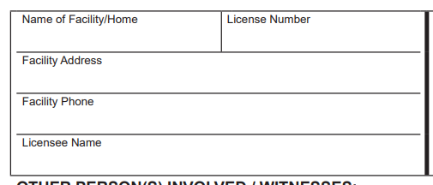
1. b. | Fill out Person Directly Involved | - Name  - Address  - City/State/Zip  - Phone  - Case Number (is possible) | 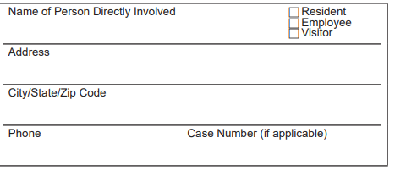
1. c. | Fill out “Other Person(s) Involved/Witnesses: | - Name  Note: Please check either Resident, Employee, and or Visitor  Note: If more than 4 people are involved, please use separate piece of paper to indicate persons. | 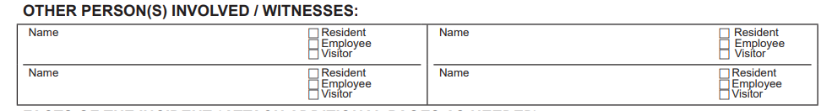
1. d. | Fill out “Facts of the Incident” | - Date  - Time (please indicate PM or AM)  - Name of Employee Assigned to Resident (if applicable)  - Location of Incident  - Explanation of what happened/description of injury  Note: Please include as much detail as possible. Answer who, what, where, why, when, and how as thoroughly as possible. If there are not enough details, WMCMH staff will contact for clarification and a response will be expected within 24 hours.  - Action taken by staff/treatment given  - Any corrective measures taken to remedy and/or prevent recurrence  - Name of Treating Physician/Treatment Facility  Note: please include the phone number, date care was given and time care was given  - Physician’s diagnosis of injury, illness, or cause of death, if known | 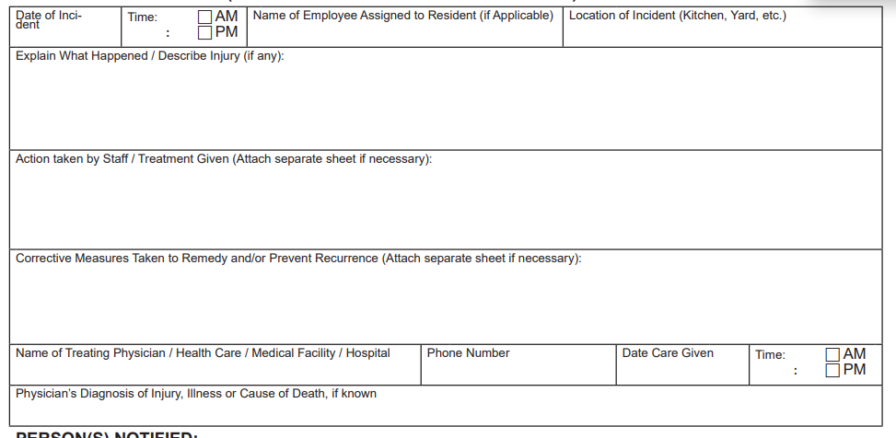
1. e. | Fill out Person(s) notified | - AFC Licensing  - Physician or RN  - Responsible Agency  - Designated Representative/Legal Guardian  - Adult Protective Service (if applicable)  - Office of Recipient Rights  - Law Enforcements  - Other (please specify) | 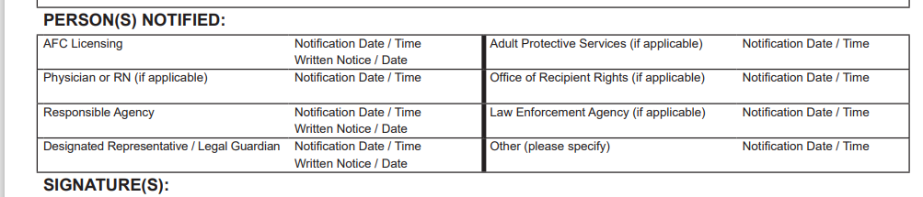
1. f. | Fill out Signature(s) | - Person completing report  Note: please print and sign with date  - Signature of Licensee/Licensee Designee/Administrator  Note: Please print and sign with date | 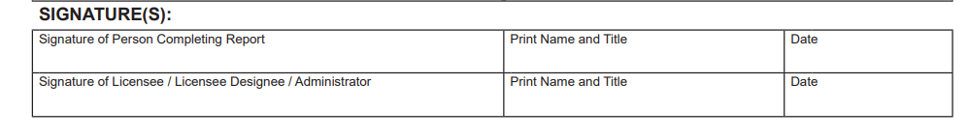
2. | Fax completed CIR form to 231-845-7095, or email via secure email to consumer_incident_reports@wmcmhs.org | Note: If you are experiencing issues with sending, please call Kristin Graham 231-845-6294 for further instruction.
3. | A Critical Incident Debriefing Analysis Form must be completed within 14 days of the incident by the Supervisor, Home Manager, or other Designee.  If the original incident report contains enough detail regarding casual factors leading up to the incident and steps staff are taking to prevent recurrence, WM may not require a separate debriefing form be filled out. | Types of Incidents requiring CIR Debriefing:  - Death  - Suicide or attempted suicide  - Emergency Medical Treatment OR Hospitalization Due To  - Injury  - Medication Error  - Self-Harm  - An individual harmed another person  - Illness (2 or More Unscheduled Admissions Not Due to Chronic Or Underlying Condition Within 365 days)  - Emergency Physical Management  - Arrest of Consumer  - Staff Called Police in Response to Consumer’s Challenging Behavior  Types of Incidents that MAY require CIR Debriefing as determined by the WMCMH Director of Network, Quality Improvement and Director of Compliance:  - Accidents, including falls that result in injury to recipient, medication errors, vehicles, or biohazards.  - Unauthorized use and possession of legal or illegal substances.  - Emergency use of Physical Management.  - Arrest of a consumer not otherwise required.  - Wandering or elopement | 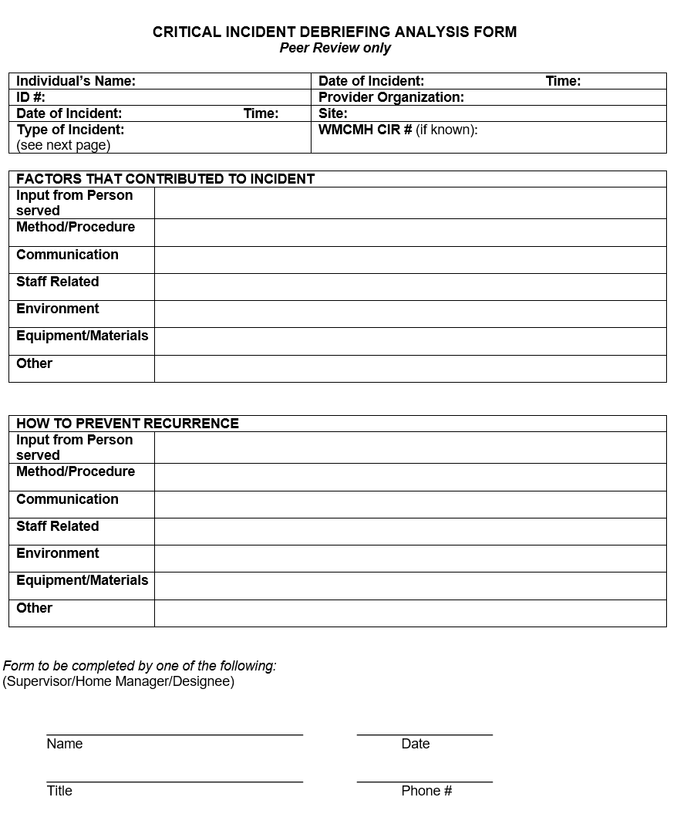
3a. | To complete the debriefing form, fill out all of the requested information in the header. | - Consumers Name  - WM CMH ID# (if known)  - Date of Incident  - Time of Incident  - Provider Organization  - Site  - Type of Incident  - WM CMH CIR# (if known) | 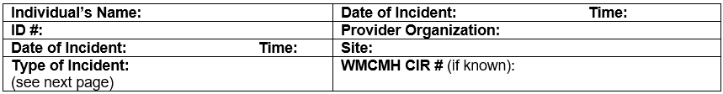
3b. | Gather information on factors that contributed to the incident. Talk with the person served, staff, and others as appropriate. Document relevant findings on the form. | Please see Page 2 of Debriefing Analysis form for considerations regarding:  - Input from the person served.  - Method/Procedure  - Communication  - Staff Related  - Environment  - Equipment/Materials  - Other | 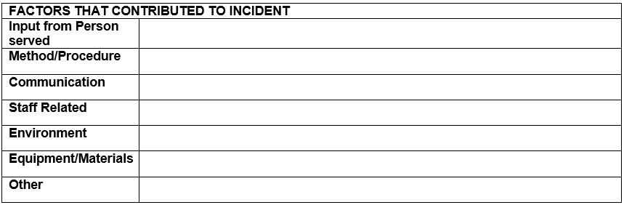
3c. | Gather ideas for how to prevent recurrence. Talk with the person served, staff, and others as appropriate. Document relevant findings in the form. | Please see Page 2 of Debriefing Analysis form for considerations regarding:  - Input from the person served  - Method/Procedure  - Communication  - Staff Related  - Environment  - Equipment/Materials  - Other | 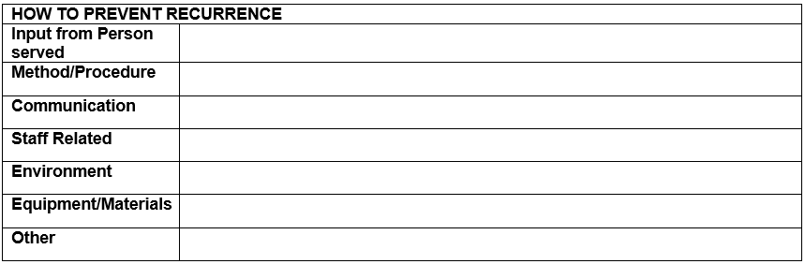
3d. | Sign and date at the bottom | Include signer’s title and contact phone number. | 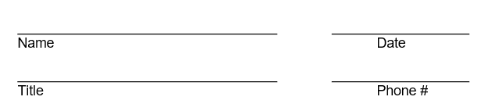
4 | Fax completed CIR Debriefing Analysis form to  231-845-7095 or email via secure email to consumer_incident_reports@wmcmhs.org | Note: If you are experiencing issues with sending, please call Kristin at 231-845-6294 for further instruction.
5 | Share the completed form with facility staff. If appropriate, use the information gathered to make improvements.

